Reminder that outstanding items will be at the top of the agenda going forward.

**Updates:**

Dan – met with Jim Malkin. Steamship will meet to have a discussion on being a good resource to the healthcare community. Dan will be following up with Jim. Christine announces that from 5-7 on Tuesday next week Stemship will have a meeting at Tis Sr Ctr where meeting attendees can ask pointed questions. Commissioners are trying to be more focused on effects on MV residents who are most affected.

Kathleen gives updates on these topics:

* Lisa and Susan deferred their topics on organizing MH/SUD services to November
* Dukes County website support for the Council content is in conversations

Vote taken on getting Victoria reimbursed $808.20 as requested by County manager. Christine moves to reimburse Victoria, Dan seconds. Discussion – Leslie asks who will pay going forward, will take over the cost? Kathleen references the County support from previous item.

**Topic: Health Effects of Climate Change. Ruth McDermott-Levy and Liz Durkee**

Liz is the Climate Change Coordinator at MV Commission. References the [Climate Action Plan](https://www.thevineyardway.org/detailed-action-plan), specifically the Public (Human) Health and Safety objectives.

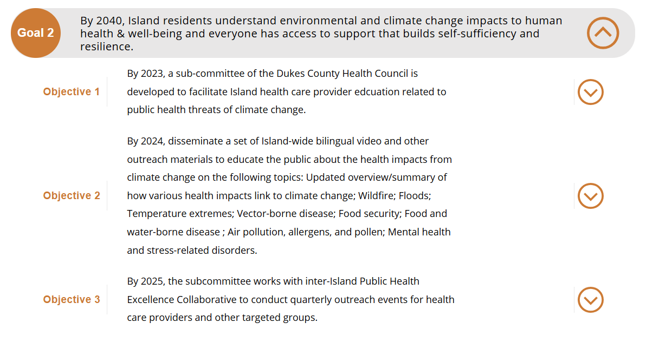

Ruth talks about the rapid changes in information on climate change and the 2022 survey of health providers on the Island, and what they know about the health effects of climate change on human health. Using a questionnaire based on research published in the Lancet, the group developed a survey of Vineyard providers. The survey only had 23 respondents (a ‘decent’ response. 6 doctors, 1 NP, 3 nurses, 2 PAs, 2 MH professionals, and 8 others (public health, allied health, pharmacy, respiratory, etc.). Asked what they believe and what they see in their practice. Identified that providers believe climate change adversely affects patient population related to vector borne disease, MH/anxiety, hunger/malnutrition, and economic hardship. Over the next 10 years, physical and mental harm from forest fires, violence and conflict/dislocation, heat/drought and related illness will be factors. Survey was done in the summer of 2022 and there was a very dry climate at the time.

The primary reason that providers stated they don’t communicate these concerns to patients is that ‘it’s too controversial’. The government is putting a lot of resources into climate change, NIH is finally paying for research in this area and is evolving. The second reason was lack of time. This is a universal state of health care visits. Third was lack of knowledge. More than half did not have any training or professional continuing education on climate change, which is to be expected of providers as most were more than 5 years out of school. Historically, schools have not have much curriculum on climate change, but there is a lot happening and newer grads are more likely to have some curriculum in this area

Highest to lowest, they would like 1. pt education materials. Federal Government invests in this type of material that can be adapted, 2. CME in climate and health, and 3. how to communicate (talking points) about climate and health to patients.

On the Vineyard, related to vulnerability on health effects of climate change, issues are:

* housing,
* SUD,
* larger group of older adults,
* low-income communities that may not have the resources to address heat or remove themselves from challenging situations,
* a fair number of second-language residents who need communication equity.

Washington Post on last Tuesday (Oct. 15) great article on effects on housing and homeowner’s insurance…they gave a link to each County – risk identifiers are low low, medium, high, Dukes County – high risk for climate issues, specifically coastal flooding, hurricanes. Emergency response is a big worry.

MV should prepare for response to extreme weather event, coastal flooding. These also factor into stress, anxiety and PTSD, longer term mold is a concern. Related to this are ticks and mosquitos (ex. west Nile) and these will become a larger concern.

Mental health issues are exacerbated during heat: anxiety, people getting very impatient (research shows that on days of high heat there are more accidents), depression and PTSD

Four areas of focus: Flooding, Mental health, Vector borne disease, Heat (Coupled with existing vulnerabilities of the population.)

Ruth calls for committee members, need funding for outreach (CDC or EPA might be sources).

Liz – adds that the survey didn’t mention that almost ½ of respondents have only been working in Vineyard health care for 1 to 3 years. This is important because long-term practitioners may have more to add – asthmas, pollen-based disease, need to add input from these long-term providers. Need to harness institutional wisdom.

Christine – thanks Ruth. How can we be proactive? I think about Dan having conversations with Jim Malkin and the Steamship, I question how prepared is the Steamship, how proactive are they in looking hurricane concerns. How are they preparing to service the Island in terms of health-related issues and supplies? What if when we do face this, cataclysmic event. It may be important to us as a Health Council to engage the Emergency Managers in one of our meetings to have the conversation about how prepared we are for a massive hurricane that might affect us not only in the off-season, when there are 20,000+ here, but perhaps in August when we have a huge number of people to deal with? ***invite the entities that could make a difference in the future?

Liz – on the note of emergency managers, Liz recently had a discussion with Chief Wirtz(sp?) about gap in Emergency services in an emergency, but what is lacking is, what are we going to do *after* an emergency? Where will people live, where will we get supplies if the boats can’t run? Liz is seeking some grant funding to addres that. Christine - adds the airport as an entity to involve in the conversation. Ruth discusses the impact on homeowner’s insurance if once the house has a roof replaced, insurance goes up. Suggests proactive use of roof clips.

Dan – given the recent hurricane in Fla, evacuation of the Island would be top of mind for a bigger emergency response (Cape might be evacuating also). People who could be evacuated would be asked to leave. Hospital could be vulnerable to damage as well.

Liz – Emergency managers’ plan for now is to shelter in place.

Dan – Hospital insurers’ plan calls for them to pay for evacuation.

Liz – we are overdue for a major hurricane and we need public discussion,

Dan – having the discussion would be tremendously helpful

Christine – maybe it’s time to have comprehensive presentation at performing arts center, not only how to deal with the emergency, but also the aftermath. Could the Health Council pull this together?

Liz – are there any members her that would be interested in joining the committee, what would the group objectives be?

Ruth - Committee melted away, hasn’t been meeting, needs members Ruth put her email addres in the chat.

Kathleen – public forum, tabletops, series of commitments. Maybe have a working meeting of this group. Could talk about how all of member organizations could be active.

Liz – stresses the importance of addressing the gap about healthcare providers knowledge about Climate change, and how to talk about it, get them the resources they need.

Christine – Marcy suggests airport could be involved to get ppl off to Boston if they have health issues.

Liz – one other point, emergency managers are not simple to contact, need to streamline contacts with them and simplify communications with the Council.

Martina – They meet monthly, and with larger group quarterly. Discussed supports that could come from MEMA. Response falls to each town, need to maintain the town resources for each EM from each town. Plan is to shelter in place except for minimal shelter for very needy residents. Supports the idea of including the Emergency managers to a meeting, can offer resources we each can contribute. Martina will share the next quarterly meeting of the emergency managers with the Coordinating Committee. She references the [Emergency Management information](https://www.dukescounty.org/emergency-management) on the Dukes County MA Website.

Dan – Coast Guard is the back-up plan for EM

Martina – The Island plan will flesh out whose role is what, the week following a catastrophic event will be hardest. In highest season, will need to get as many people off as possible.

Mike W – talks about MRC, official US Public Health Service. Used to be on the Vineyard, but not so much now. Could we revive that?

Someone very broken up here … Martina? Capacity of MRC reduced after the paid person wasn’t in place. Liability insurance was an issue during COVID, hospital couldn’t enlist the MRC. Mike – could this come back, Kathleen – where it *could* fit?

**Topic – Reconstituted Nominating Committee. Leslie Clapp**

We have a new nominating committee, Leslie Clapp, Kathleen Samways, Marcy Holmes, Susan Sanford, Lew Laskaris. Developing a letter of invitation and web-based application. # members who have been applicants: bios were attached to the Oct 17 Agenda. Dr. Micheal Wertheimer, Amelia Hambrecht, Lisa Belcastro. Moved, seconded, discussion: none. Voted unanimously. No opposition. Will be forwarded to the Dukes County Commissioners for appointment.

**Topic: Department of Conservation and Recreation. Christine Todd/Dan Doyle**

Productive meeting with DCR earlier this week, then held a public meeting. Well-attended meeting, addressed 4 large topics. Specifically, the handling of the homeless encampment in the forest.

Dan Doyle – productive meeting from DCR Commissioner who sees the forest as an asset

Manuel F. Correllus State Forest Task force has 4 objectives:  
1. Remove non-native forestation

2. Wildfire mitigation effort

3. Get the house occupied (state forest superintendent)

4. Get the final 7.5 miles of shared use path repaved

Christine – the forest cannot allow anyone to live in the house in the forest. Potential for using a chunk of land for affordable housing, which would need legislation of its own. There are a lot of folks who do not want to disturb the forest. This is a complex issue but Dan’s group will be communicating with DCR to improve management and health of the forest and developing goals going forward. Initial conversation has started. Shared path is a concern; electric bikes are also using the paths. Paths provide access to move around and be healthy.

Kathleen – who is on the group looking at the forest? Dan - Founding member of Friends of Manuel Correllius Forest (Bob Woodruff), 2 fire chiefs (EDG and West Tis), ecologists from involved planning and conservation groups, a couple of people from DCR are members.

Leslie – is there Tribal representation on the Committee? Dan – drove some invitations up to the Tribe. Commission wants the Tribe to inform the Commission on the most native use of the land. They responded that they were only interested if there were major disturbances. Dan – Cmn continues to be interested in getting the Tribe involved.

Christine and Marcy - history of the forest is effective management by the Tribe before it was established as a State Forest. Recommends stewards look at that origin as a model of good management.

Christine acknowledges the participation of folks who came to express their concerns. Seeks an apology for how things were handled.

Martina – DCR did promise to coordinate with local agencies if they plan any action. Brian Morris from Harbor Homes as well as the Boards of Health should be involved. In the past the Council has expressed concerns about wildfire. She references a homeowner ‘course’ that can be attended to learn how to prepare for or prevent local fire. Get this training link from Martina.

Leslie – thanks Martina for the info and asks how to access it.

Dan Doyle – wildfire home assessment training is for someone to DO the training with other homeowners. (District Fire Manager Josh Nigro has information on this) On the County website News 4th item down

Dan thanks Center 4 Living for visit to the forest

Martina suggests that we can contact our own fire dept for individual actions

Kathleen – references a Dodger’s Hole initiative, an abutter yard cleanup. These are one-off events.

Leslie - asks where this information is located

Christine – re: information to abutters. How can we get that information to abutters?

Dan – Association boundaries and homeowners’ addresses being complied by an intern at the Commission. This will help with its Strategic Plan

Lenore – Idea as part of proactive on wildfire and coordinated response to homeless.

1. Understand who is coordinating for some of the people
2. Health Agent meeting/Agents coordinate and when we get calls about homeless people residing in public property, can contact Harbor Homes or can we have a list of who to contact?

**Topic: PH update. Kathleen Samways**

* Vax bus. Oct 26, will forward to Council members. Will do both COVID and Flu
* Leslie’s closure. D&I Committee at Sept end, we talked about the Council addressing information about Leslie’s closure. Victoria made that the Health Council’s September column. It became the Times and Gazette coverage on Leslie’s.
  + Christine – re: Leslie’s. Shout out to pharmacies that stepped up when Lelsie’s pharmacy had to close. They are doing the best they can, have done very well under the circumstances.

Conclusion.

Respectfully submitted.